Praktikum Soal 1:

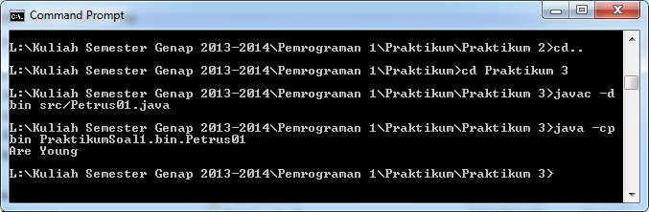

Praktikum Soal 2:

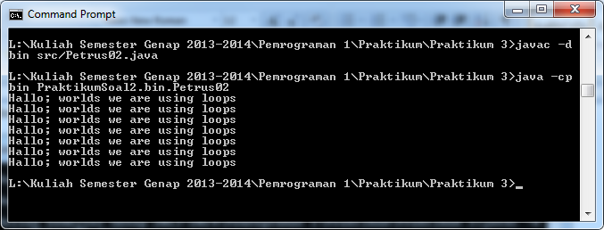

Praktikum Soal 3:

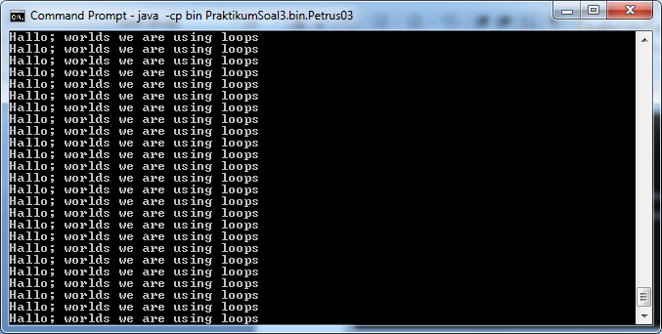

Praktikum Soal 4:

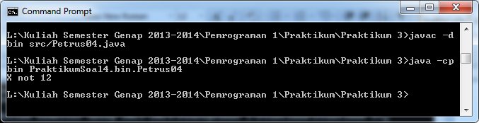

Praktikum Soal 5:

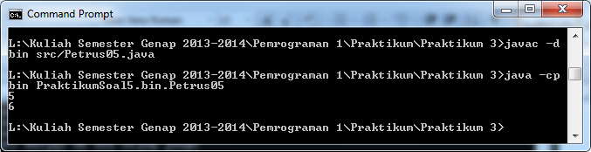

Praktikum Soal 6:

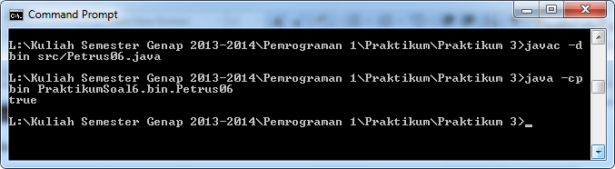

Praktikum Soal 7:

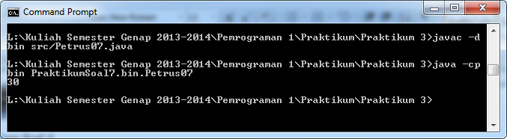

Praktikum Soal 8:

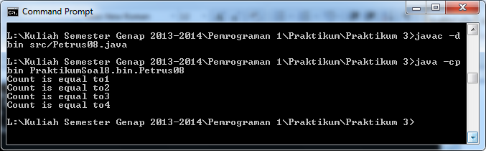

Praktikum Soal 9:

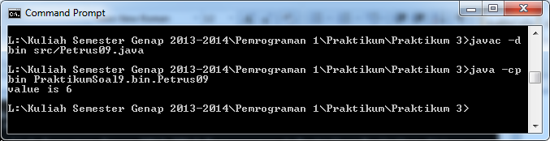

Praktikum Soal 10:

